Salish Salmon in Landing Page
At first, we did have the Salmon on the Landing Page, so I did a recheck and made sure it was still there:
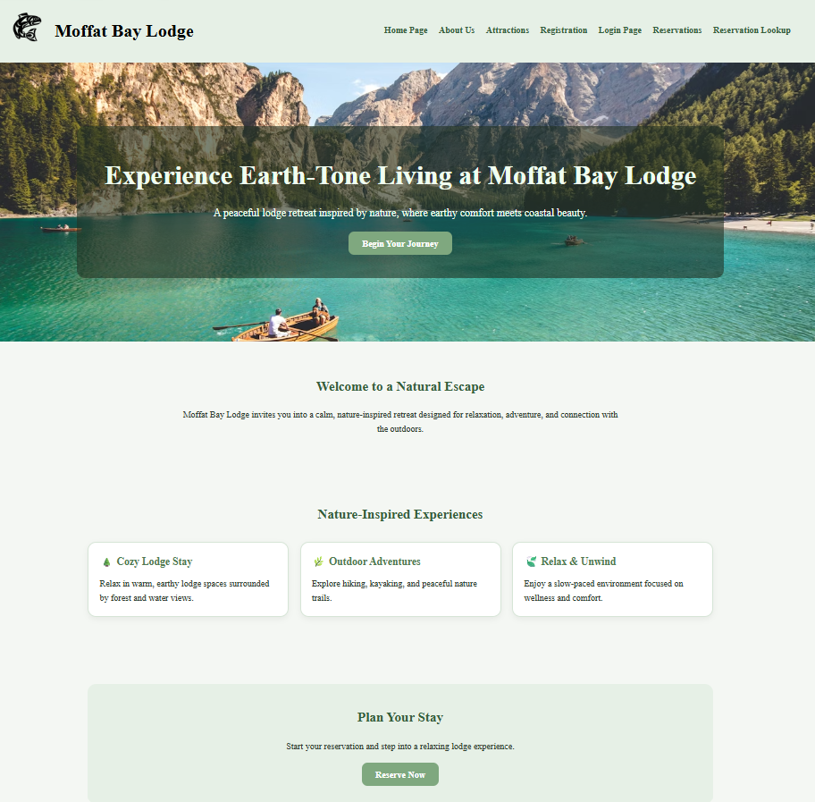

Add in Criteria for Password
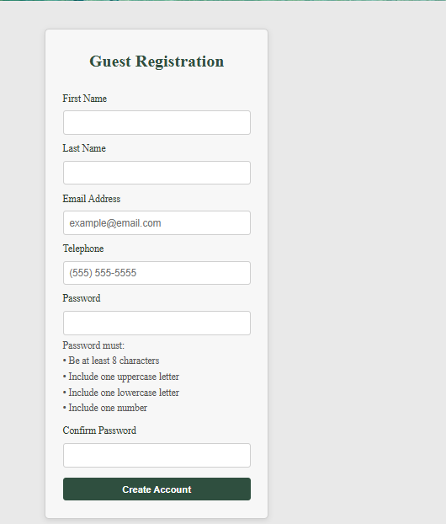

Created a Check Out Section for Reservations
